Da Boot

Bug submission and tracking software

By: Max Ooi Wei Xiang

**Table of Contents**

Context 1

Goals and Non-Goals 1

Proposed Technical Architecture 1

User-Interface 2

Database Design 6

Milestones and Timeline 6

# Context

The aim of this project is to provide an platform for developers and contributors to track bug fixes over time. Developers can subsequently send links to software users to submit bugs directly.

# Goals and Non-Goals

The goals of this project are:

* User Authentication and Authorization, using both username+password and Oauth method
* Unauthenticated users can submit bugs only and register/sign in to be a tester
* Authenticated users can search for users and be a tester without approval
* Different roles for each project, with each role being able to perform the previous roles’ tasks:
  + Tester – Submit and view past bug tickets, request for promotion to developer
  + Developer – Close, edit, assign and comment on bug tickets, request for lead switch
  + Lead – Create projects, approve role elevation and lead switch, promote and demote all users within the project
* Each ticket has submission, assignment and plan-closeout and closeout date, color coded based on urgency.
* Demotion-lock, if users are assigned tickets

The non-goals of the project, which could be of interest in the future, are

* Progress checking and milestones for each ticket
* Email alerting

# **Proposed Technical Architecture**

The proposed tech stack used for this project is ASP.NET Core with C#, on an MVC framework. Back-end database is provided by MySQL running on AWS RDS.

## User-Interface

Main dashboard

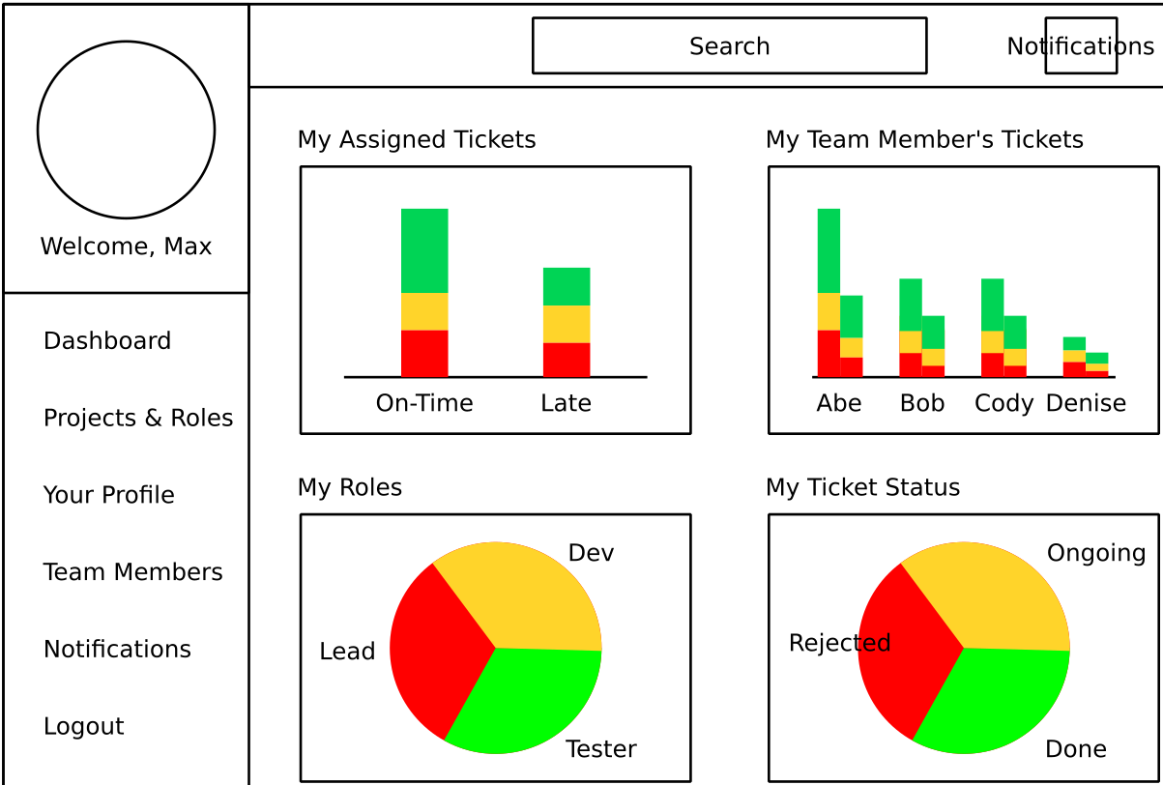

Projects and Roles

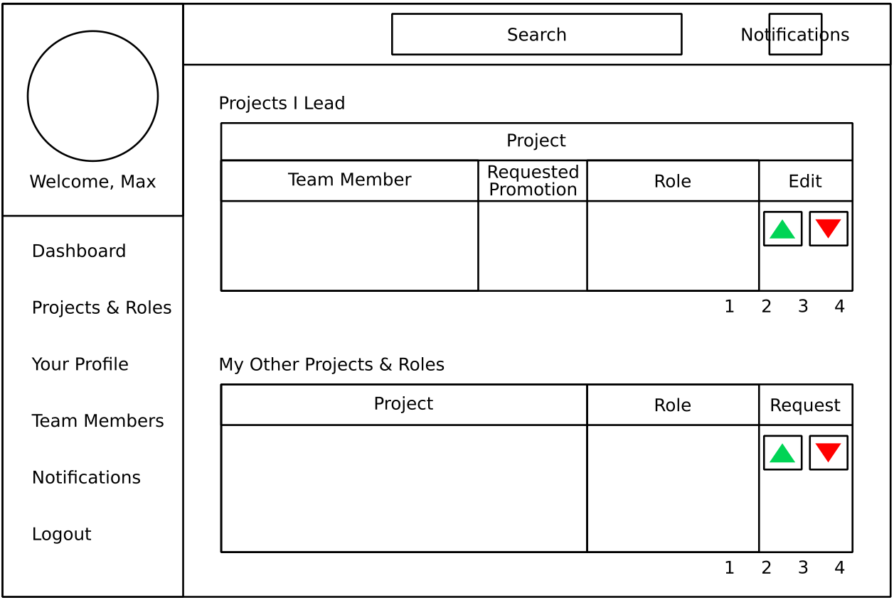

User profile

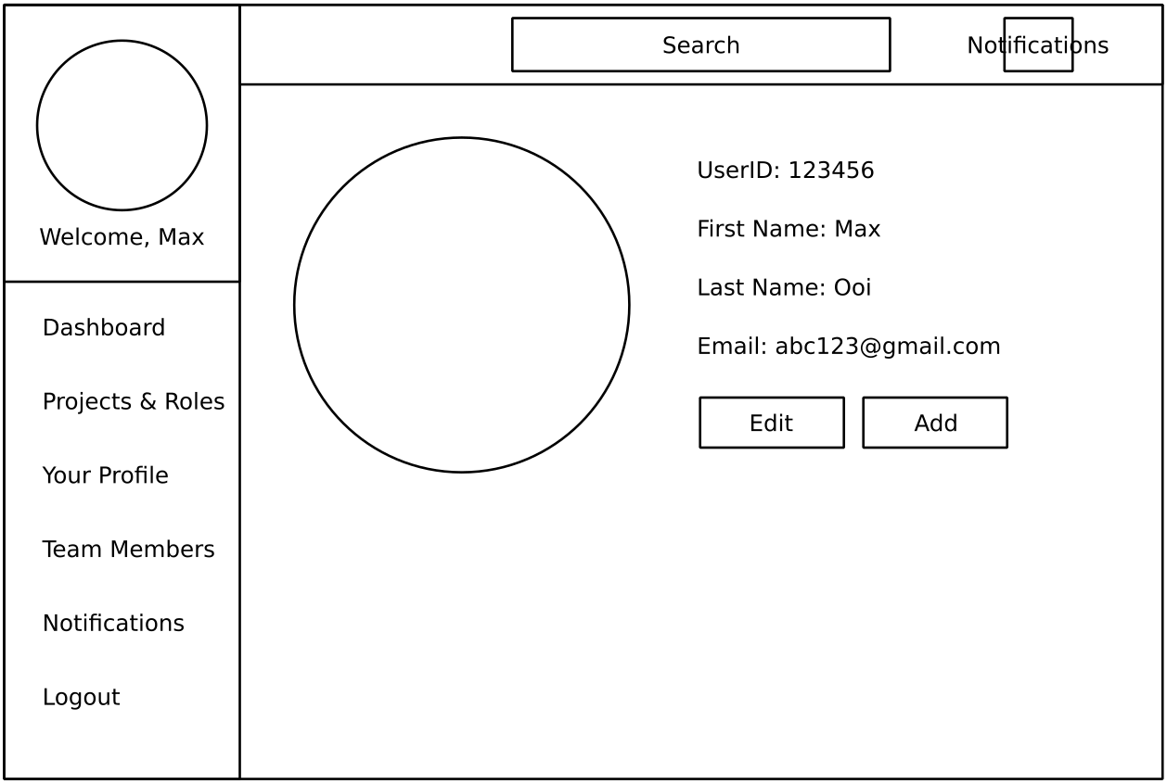

Team Members view

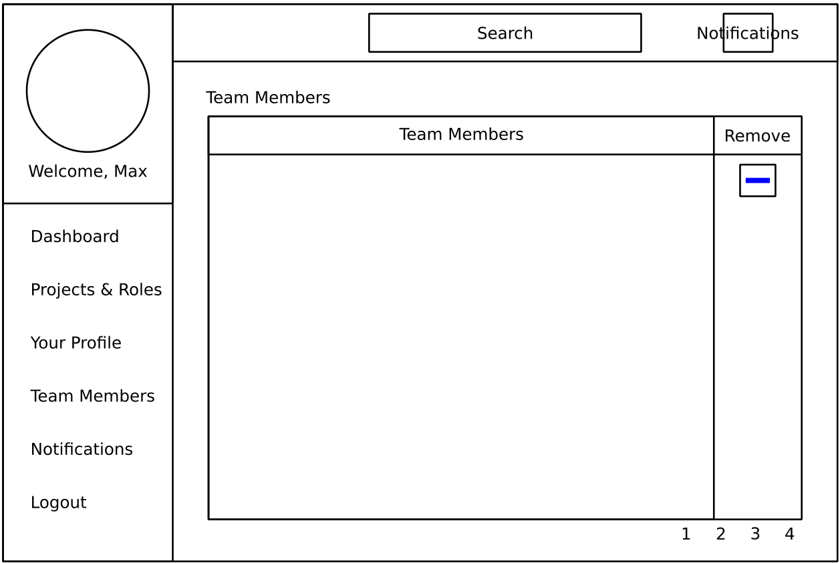

Search Results

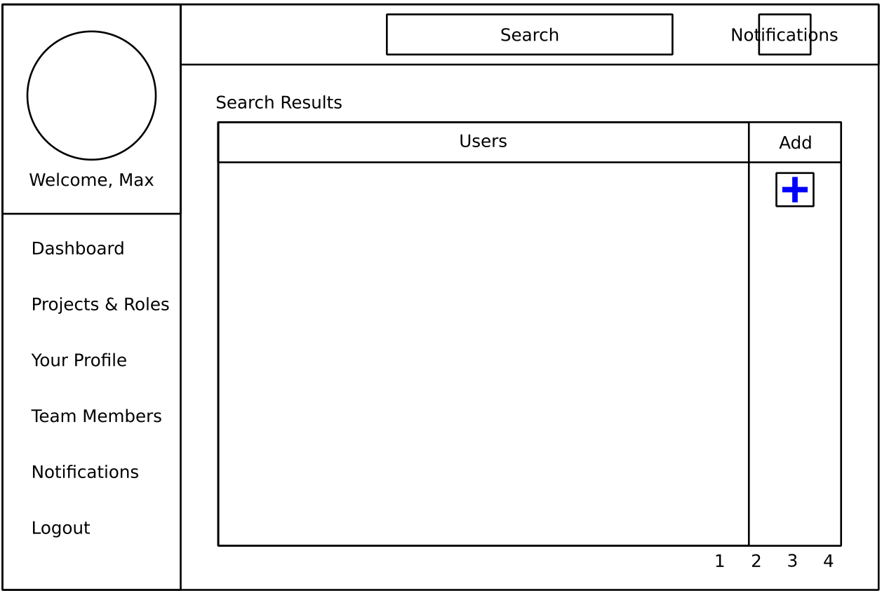

Single Project view

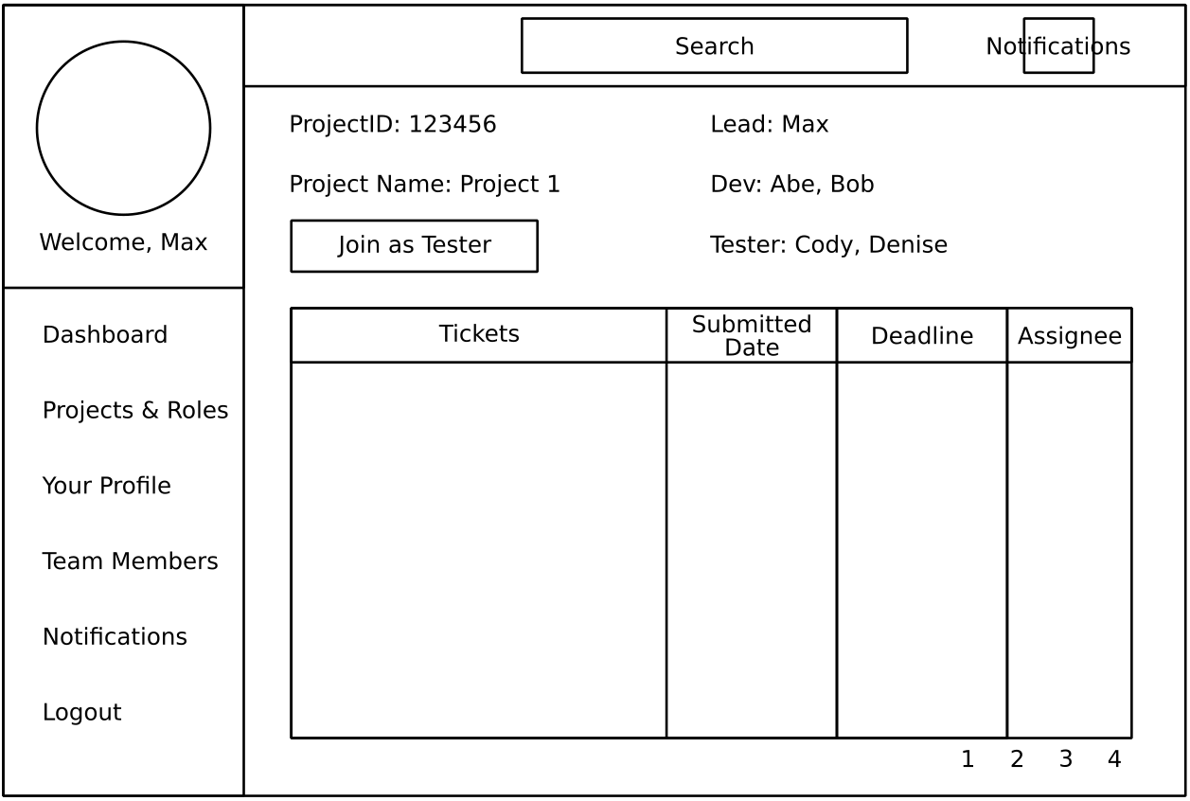

Ticket

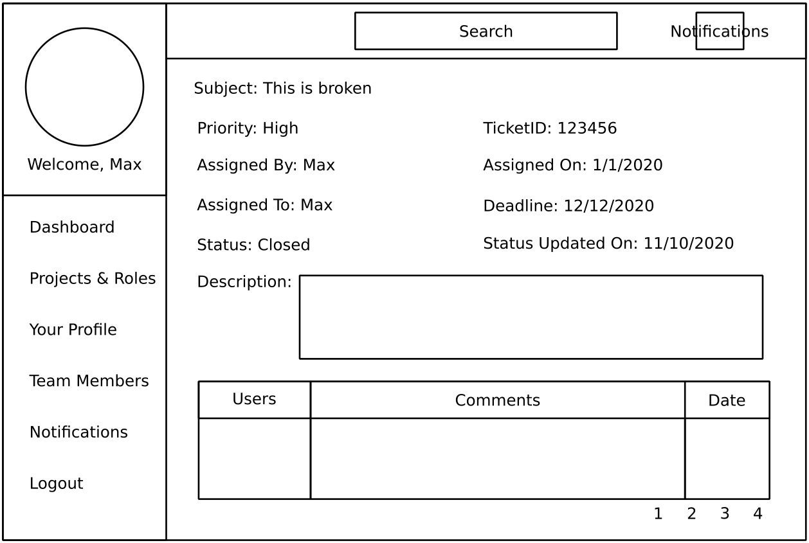

Notifications

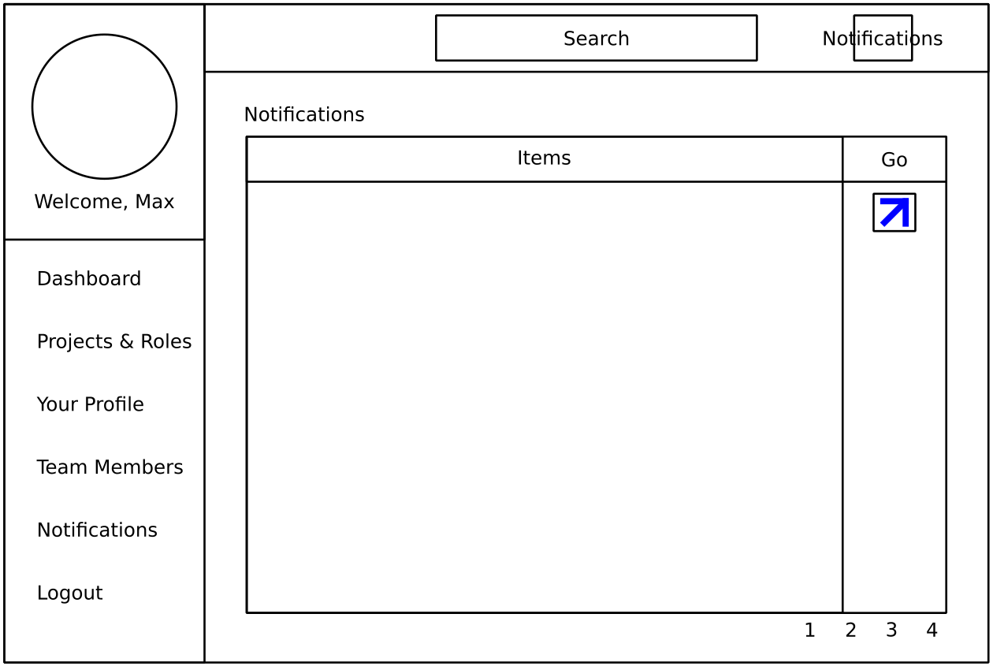

## Database Design

Preliminary database design is as below:

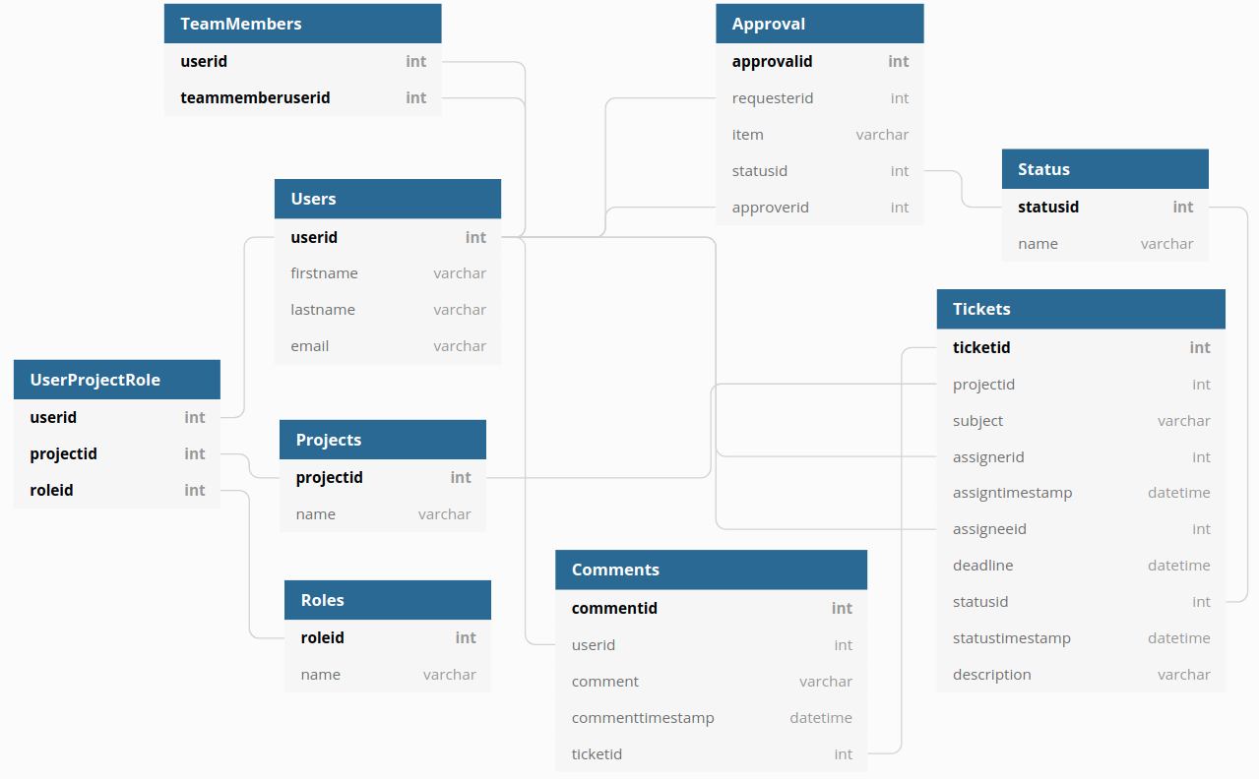

# Milestones and Timeline

|  |  |  |  |  |  |  |  |  |  |
| --- | --- | --- | --- | --- | --- | --- | --- | --- | --- |
| Month | Sept | | | | | Oct | | | |
| Day | 1 | 8 | 15 | 22 | 29 | 6 | 13 | 20 | 27 |
| **Items** |  |  |  |  |  |  |  |  |  |
| Authentication and Authorization | x |  |  |  |  |  |  |  |  |
| Data Model |  | x |  |  |  |  |  |  |  |
| Projects & Roles, TeamMember UI |  |  | x |  |  |  |  |  |  |
| Ticket UIs |  |  |  | x |  |  |  |  |  |
| Break |  |  |  |  | x |  |  |  |  |
| Dashboard UI |  |  |  |  |  | x |  |  |  |
| Notifications |  |  |  |  |  |  | x |  |  |
| Bug fixes, deployment and buffer |  |  |  |  |  |  |  | x | x |